**Top IT Certifications in 2025: Skills That Will Get You Hired**

In 2025, [**cloud computing**](https://aws.amazon.com/what-is-cloud-computing/), [**cybersecurity**](https://www.cisa.gov/), **data analytics**, and **project management** remain central to digital transformation across industries. **IT certifications** have become essential for professionals aiming to validate their **skills and knowledge**, improve job prospects, and command higher salaries.

Whether you’re seeking to enter the field or **advance your career**, this guide explores the **top certifications to pursue in 2025**, tailored to the evolving **job market** and industry trends.



**Most In-Demand Certifications for 2025**

Technological advancements, evolving threats, and the dominance of **cloud platforms** are shaping the **certification** landscape. Here are the **in-demand certifications** that align with these trends:

**1. Cloud Computing Certifications**

* [**AWS Certified Solutions Architect**](https://aws.amazon.com/certification/certified-solutions-architect-associate/)
* **Google Professional Cloud Architect**
* [**Microsoft Certified: Azure Solutions Architect Expert**](https://learn.microsoft.com/en-us/certifications/azure-solutions-architect/)

These **cloud computing certifications** validate your ability to design secure and scalable **cloud architecture** using platforms like **AWS**, **Google Cloud**, and **Microsoft Azure**.

**2. Cybersecurity Certifications**

* [**Certified Information Systems Security Professional (CISSP)**](https://www.learnologyworld.net/products/cissp-certified-information-systems-security-professional-exam-voucher-–-isc2/5224517000001438465)
* **Certified Information Security Manager (CISM)**
* [**Certified Cloud Security Professional (CCSP)**](https://www.learnologyworld.net/products/certified-cloud-security-professional-ccsp-exam-voucher-–-isc2/5224517000001438347)

These credentials emphasize **security and risk management**—crucial in protecting enterprise data and infrastructure.

**3. Networking Certifications**

* **Cisco Certified Network Associate (CCNA)**
* [**CompTIA Network+**](https://www.learnologyworld.net/products/comptia-network-n10-008-voucher/5224517000000098481)

Ideal for aspiring **network engineers**, these **networking certifications** cover essential **network** protocols, troubleshooting, and security.

**4. Project Management Certifications**

* **Project Management Professional (PMP)**
* **Certified ScrumMaster (CSM)**

**Project management** credentials equip professionals with skills to manage projects efficiently and follow **best practices** across agile and traditional methodologies.

**5. Data and Analytics Certifications**

* [**CompTIA Data+**](https://www.learnologyworld.net/products/comptia-data-da0-001-voucher/5224517000000478057)
* **Google Data Analytics Certificate**
* **Business Analyst Certifications**

As organizations become increasingly **data-driven**, these certifications help **validate** expertise in data interpretation, visualization, and analytics tools.

**6. Entry-Level IT Certifications**

* [**CompTIA A+**](https://www.learnologyworld.net/products/comptia-a-exam-220-1101-or-220-1102-voucher-with-free-dumps/5224517000000098469)
* [**CompTIA Security+**](https://www.learnologyworld.net/products/comptia-security-voucher/5224517000000098493)
* **Google IT Support Professional Certificate**
* [**Microsoft Fundamentals (Azure, 365)**](https://www.learnologyworld.net/categories/microsoft-certification/5224517000001331119)
* **Cisco CCNA**

An **entry-level certification** provides a strong foundation for launching an IT career, especially for those lacking **work experience**.

**How to Choose the Right Certification**

Choosing the **right certification** involves aligning your goals, experience, and industry demand:

1. **Define Career Goals**: Identify your path—**cybersecurity analyst**, **cloud architect**, **project manager**, etc.
2. **Assess Skill Set**: Evaluate current capabilities and determine what needs improvement.
3. **Research Demand**: Use [LinkedIn Jobs](https://www.linkedin.com/jobs/) or [Indeed](https://www.indeed.com/) to see which **certifications signal** employer interest.
4. **Review Prerequisites**: Understand what each **certification exam** requires.
5. **Consider ROI**: Weigh the cost, time, and long-term value.
6. **Choose Reputable Bodies**: Opt for providers like [**CompTIA**](https://www.comptia.org/)**,** [**Microsoft Learn**](https://learn.microsoft.com/)**,** [**AWS Training**](https://aws.amazon.com/training/)**, or** [**Cisco Learning**](https://learningnetwork.cisco.com/) for globally recognized **credentials**.

**How Certifications Validate Your Skills**

**Professional certifications** offer measurable, objective validation that your skills meet industry standards. Here's how:

* **Standardized Skill Verification**: Through exams or practicals, **certifications demonstrate** your readiness.
* **Employer Recognition**: Employers value **certified professionals** from institutions like [ISC²](https://www.isc2.org/) and [ISACA](https://www.isaca.org/) when screening candidates.
* **Career Advancement**: **Certifications help professionals** gain credibility, leading to promotions and **higher pay**.
* **Bridging Skill Gaps**: A **certification helps** you pivot into new fields like [**AI**, **cloud computing**](https://www.coursera.org/articles/machine-learning-careers), or **information security**.
* **Community Access**: Some programs offer access to global **certification** communities and exclusive resources.

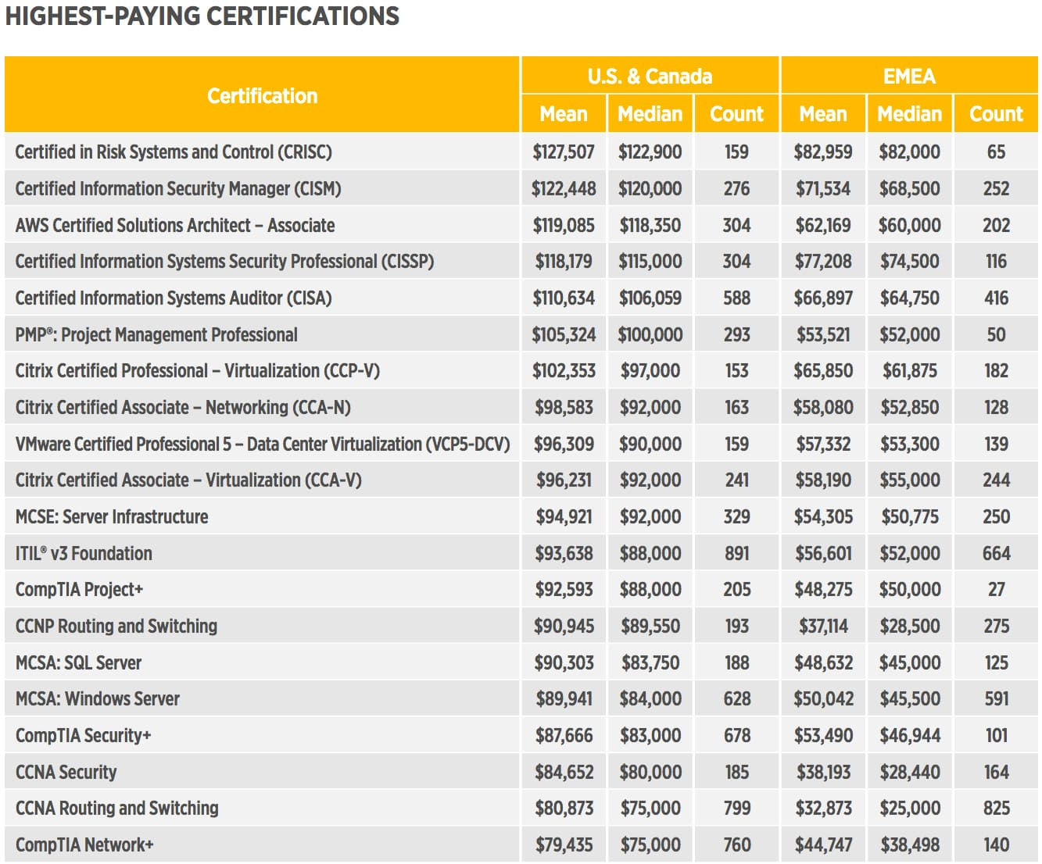

**Highest-Paying IT Certifications in 2025**

These **certifications provide a clear** path to strong salaries in today’s market:

**Top U.S. Salaries (2025)**

* AWS Certified Security – Specialty: $203,597
* Google Professional Cloud Architect: $190,204
* CISSP: $168,060
* CCSP: $171,524
* AWS Certified Solutions Architect – Associate: $155,597
* CISM: $157,189
* Microsoft 365 Certified: Administrator Expert: $160,044
* CRISC, CISA, CIPM, CEH, and others also rank highly

**Top Global Salaries (2025)**

* ISSMP: $188,291
* AWS Certified Machine Learning – Specialty: $171,725
* Microsoft Certified: Azure Cosmos DB Developer: $178,304
* CDPSE, CCSE, CCIE, and other **technical certifications** continue to offer global earning potential

**Best Certifications for Beginners**

If you're **looking to advance** from the ground up, these **certifications to get** started are ideal:

| **Certification Name** | **Focus Area** | **Ideal For** |
| --- | --- | --- |
| **CompTIA ITF+** | General IT basics | Beginners, career switchers |
| **CompTIA A+** | Hardware, support | Help desk, tech support |
| **CompTIA Network+** | Networking basics | Network support/admin |
| **Google IT Support Certificate** | Troubleshooting, security | Entry-level IT support |
| **Microsoft Fundamentals** | Cloud, productivity | Cloud/365 newcomers |
| **Cisco CCNA** | Networking | Aspiring **network engineers** |
| **Microsoft Technology Associate (MTA)** | Programming, databases | Microsoft technologies |

**[](https://www.learnologyworld.net/index)**

**Why Entry-Level Certifications Matter**

**Certifications provide measurable** proof of expertise, even without formal degrees:

* **Credibility**: Shows commitment to the field.
* **Job Market Visibility**: Helps stand out in a competitive pool.
* **Skill Demonstration**: Covers **essential skills** like troubleshooting, security, and **operating systems**.
* **Expanded Access**: Opens doors to roles across sectors.
* **Earning Potential**: Entry-level **certified professionals** often earn more and **advance their careers** faster.

**Certifications in 2025** remain vital tools for professionals in tech. From **developer certifications** to **cloud solution** design and **risk management**, there's a credential for every stage of your journey.

Whether you're seeking your first job or targeting the **highest-paying IT certifications**, **training and certifications** will help you **stay ahead** in an evolving digital world.

**Certifications aren’t** just about passing an exam—they're about proving value, expanding your expertise, and unlocking new opportunities.

**Discover the top** paths that can redefine your future—because the **best certifications** don’t just fill resumes; they **equip** professionals for long-term success.

SEO Title: Top IT Certifications in 2025: Skills That Will Get You Hired

SEO Description: Discover the top IT certification for 2025. Get in-demand certifications & cybersecurity skills. Stay ahead with a valuable credential & highest-paying IT certifications.